**Exercice Le refactoring**

**Amélioration d’un code difficile**

L’application proposée semble très simple lorsqu’on regarde le modèle de classe, mais est bien complexe si on examine le code.

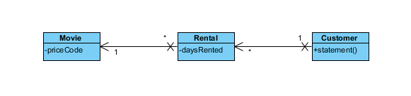

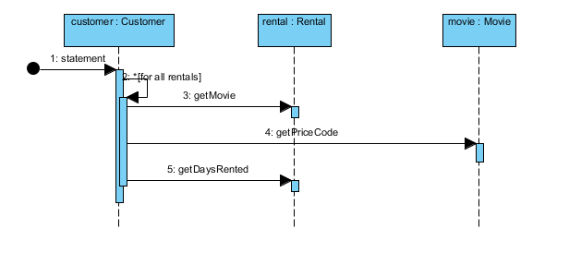

**public** **class** Movie {

**public** **static** **final** **int** *CHILDRENS* = 2;

**public** **static** **final** **int** *REGULAR* = 0;

**public** **static** **final** **int** *NEW_RELEASE* = 1;

**private** String _title;

**private** **int** _priceCode;

**public** Movie(String title, **int** priceCode) {

_title = title;

_priceCode = priceCode;

}

**public** **int** getPriceCode() {

**return** _priceCode;

}

**public** **void** setPriceCode(**int** arg) {

_priceCode = arg;

}

**public** String getTitle() {

**return** _title;

}

}

**public** **class** Rental {

**private** Movie _movie;

**private** **int** _daysRented;

**public** Rental(Movie movie, **int** daysRented) {

_movie = movie;

_daysRented = daysRented;

}

**public** **int** getDaysRented() {

**return** _daysRented;

}

**public** Movie getMovie() {

**return** _movie;

}

}

**import** java.util.*;

**public** **class** Customer {

**private** String _name;

**private** Vector _rentals = **new** Vector();

**public** Customer(String name) {

_name=name;

}

**public** **void** addRental(Rental arg) {

_rentals.addElement(arg);

}

**public** String getName() {

**return** _name;

}

**public** String statement() {

**double** totalAmount = 0;

**int** frequentRenterPoints = 0;

Enumeration rentals = _rentals.elements();

String result = "Rental Record for "+getName()+"\n";

**while**(rentals.hasMoreElements()) {

**double** thisAmount = 0;

Rental each = (Rental)rentals.nextElement();

**switch**(each.getMovie().getPriceCode()) {

**case** Movie.*REGULAR* :

thisAmount += 2;

**if**(each.getDaysRented() >2)

thisAmount += (each.getDaysRented() -2 ) *1.5;

**break**;

**case** Movie.*NEW_RELEASE* :

thisAmount += each.getDaysRented() * 3;

**break**;

**case** Movie.*CHILDRENS* :

thisAmount += 1.5;

**if**(each.getDaysRented() > 3)

thisAmount += (each.getDaysRented() -3 ) *1.5;

**break**;

}

frequentRenterPoints ++;

**if**((each.getMovie().getPriceCode() == Movie.*NEW_RELEASE*) &&

each.getDaysRented() > 1) frequentRenterPoints ++;

result += "\t"+each.getMovie().getTitle()+"\t"+

String.*valueOf*(thisAmount) +"\n";

totalAmount += thisAmount;

}

result += "Amount owed is "+String.*valueOf*(totalAmount) +"\n";

result += "You earned "+String.*valueOf*(frequentRenterPoints)+

"frequent renter points";

**return** result;

}

}

**Améliorer le modèle et le code initial.**